Home learning tasks
This Photo by Unknown Author is licensed under CC BY-SA
Week 3: Monday 15th June 2020

Geography
Watch the video on youtube called ‘Barnaby Bear goes to Edinburgh’ https://www.youtube.com/watch?v=Fa5_MHHij4E
Listen out for some geography words
Capital city, east coast, buildings, river, port, hill, castle, rock, park, railway

As you watch Barnaby bear tour around the castle:
What do you see ? How is the castle laid out ? What do you find out ?

After watching the first 5 minutes of the video you could either:
Draw a map of the route Barnaby bear took in the castle (remember like the map we draw of your journey from home to school in the Autumn)
OR draw pictures about 4 or 5 new words that you have learnt.
You might wish to rewatch the video to help you. If you have time, you could watch the rest of the video as Baranby visits other parts of Edinburgh.

SCIENCE
Watch the first half of the ‘youtube’ video called Sea life London Aquarium (dated April 2014)
https://www.youtube.com/watch?v=Si1twh8YQu8
Choose 2 or 3 fish that you like and draw a picture of them carefully noticing the patterns and shape. You could pause the video to draw each one.
Find out the name of the fish and label where the gills, fins and tail are on each one.

COMPUTING https://www.childnet.com/resources/smartie-the-penguin
Ask someone at home to read the Smartie the Penguin slide show. Talk together at different parts of the story about what you would do to stay safe.
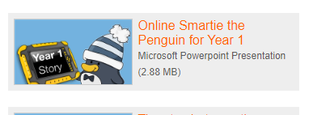
You could draw a picture of Smartie with a speech bubble saying how to stay safe.

