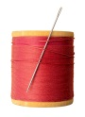Learning to Sew! 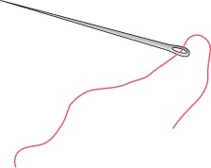

This week we would like you to spend some time learning how to sew.

Don’t worry if you haven’t sewn before. There are some video clips for you to watch which will explain how to sew.

What you will need:
- An adult to supervise you doing this activity.
This is very important. We do not want you doing this on your own.
- A sewing needle.
- A piece of thread.
- Scissors.
- A small piece of material.

Please click on the link below to learn how to sew using overstitch.
https://www.youtube.com/watch?v=gmD9vpo5Fso
Now you can practise this sewing stitch. You might want to watch the video again to make sure you have got it right.

Please click on the link below to learn how to sew using running stitch.
https://www.youtube.com/watch?v=i1-B01FB56s
Now you can practise this sewing stitch.

Which sewing stitch did you prefer?

The link below shows how to sew on a button.
https://www.youtube.com/watch?v=8mIGGn3AS1E
Now give it a try yourself.

I do hope you have fun learning this new skill.

I can’t wait to see how you got on.

