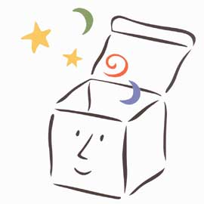
Today please listen to Kit Wright reading his poem ‘The Magic Box’.
https://www.bbc.co.uk/bitesize/clips/zkpmhyc
There is also a copy of the poem with the home learning.
Why do you think he chooses these things to go in his box?
Are they special to him?
Are they all objects?
Some of the things in his box are feelings, sounds or actions.
Would all the actions fit in a real box?
Luckily this one is magic!
Find out the answers to these questions:
- Where is Lake Lucerne?

___________________________________________________________________________________
- Where do people speak Gujarati?

___________________________________________________________________________________
- What is a breaker?

___________________________________________________________________________________
Now choose your favourite thing that goes in the box and draw a picture of it in your red book.

