Creative Week for Larks – 29th June to 3rd July
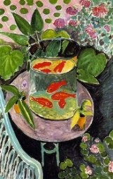  Matisse | 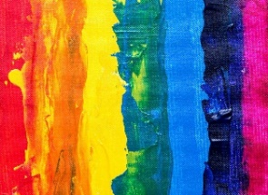  Colour | 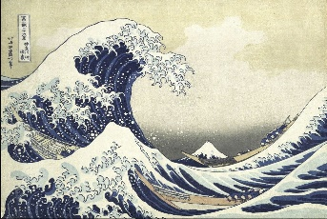  Hokusai | 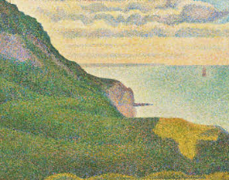  George Seurat | 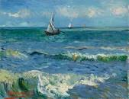  Van Gogh
Monday | Tuesday | Wednesday | Thursday | Friday
- Look at Henri Matisse painting Goldfish, 1912. Does it look real? Do you like the painting? Why? Look at the painting for 2 minutes, then cover it and describe it to someone.  - If you have fish at home watch them swimming, otherwise watch these fish  https://www.youtube.com/watch?v=cC9r0jHF-Fw  - Can you think of some verbs to describe how the fish moves ? glides, swish  - Write some describing words for colour, shape, size (adjectives) about a fish.  - Using these words write an acrostic poem using the word ‘GoldFish’. E.g.  Gliding fish silently,  Orange shiny scales,  Large tail swish,  Dancing fish shimmer…..  - Look at your fish at home or Google fish and have a go at drawing a fish, looking really carefully at the lines and shapes. Use a pencil or pen to draw.  Trout are a good shape to draw.  Remember ‘more looking, less drawing’. | - Colours are an important part of art. Artists choose their colours carefully. Today we are going to think about colour. The rainbow walk idea came from this website…  https://www.tate.org.uk/kids/make/cut-paste/go-on-colour-walk  - At home, go on a rainbow walk. Collect a manmade and natural object (just as a photo if appropriate) for each colour.  - Create a rainbow map of where you went and where you found each thing.  - Learn to sing the rainbow song … https://www.youtube.com/watch?v=4g0NbaukkQc  - Paint a rainbow, colour-mixing the primary colours (red, yellow, blue) to make the secondary colours.  - Challenge; Now add blue, red and yellow together. What colour does this make ? Can you add more red or blue to make brown ? | - Look carefully at the print by Hokusai ‘The Great Wave’. How many different tones of blue can you see?  Do the blues get lighter or darker?  What happens when you add a little bit of white to blue? Repeat but with a little bit of black and blue.  - Can you create a colour chart of blue with more and more white added and a chart with more black added each time? (Parents see the attached sheet and think colour paint charts that you would get from a DIY store.)  - Look carefully at the shape of the wave in the print by Hokusai.  Watch this video  (first 2 minutes then move onto 5mins to the end )  https://www.youtube.com/watch?v=O0BgKCm_R9k  - Can you draw your own wave, as large as possible on a piece of paper. You might like to look at photographs of waves to help you.  - Now mix the tones of blue, lighter and darker to paint your own painting of a wave. Add white for the froth of the wave. Mix a light colour to paint the sky behind. When your painting has dried, use a felt-tip or black biro to draw the outline of the wave and the froth.  - Are you pleased with your painting ? Why ? Have you used lots of tones of blue ? | https://www.happyfamilyart.com/art-lessons/art-history-for-kids/pointillism-georges-seurat-art-lesson/  - Look at George Seurat’s painting Seascape at Port-en-Bessin, Normandy 1888. What can you see? Do you like the painting? Why/why not? Look at the painting for 2 minutes, then cover it and describe it to someone.  - Today, we are going to focus on Seurat’s pointillism style of painting and paint our own seascape using pointillism. Draw a seascape picture with simple lines for the sea, sky and sand etc. You can use a seascape photo to help. On a large piece of paper (fill the whole page), draw those simple lines. Are you happy with what you have drawn? What would you like to change? Have another go.  - Experiment with using cotton buds and the tip of different sized paintbrushes to make small paint marks with the tip.  - Listen to this sea music whilst you are painting. It is composed by Debussy and called La Mer (the sea). Do you like it? https://www.youtube.com/watch?v=nn0tZHOuTKQ  - When you have finished your painting stand back to look at it. Evaluate your work. What went well? What would you do differently next time? | - Look at Van Gogh’s painting The Sea at Les-de-La-Mer, 1888. What can you see? Do you like the painting? Why/why not? Notice the brushstrokes. Look at the colours. Look at the painting for 2 minutes, then cover it and describe it to someone.  - Compare George Seurat with Van Gogh. How are their paintings different? What is similar? Notice the year they were both painted. Which style of painting do you prefer?  - Paint your painting from yesterday in the style of Van Gogh. Paint freely using big brushes and bold colours.  - When you have finished put your painting from today next to the painting you did yesterday. Which do you prefer and why?

