Class 1 Planning – 6th – 10th July 2020
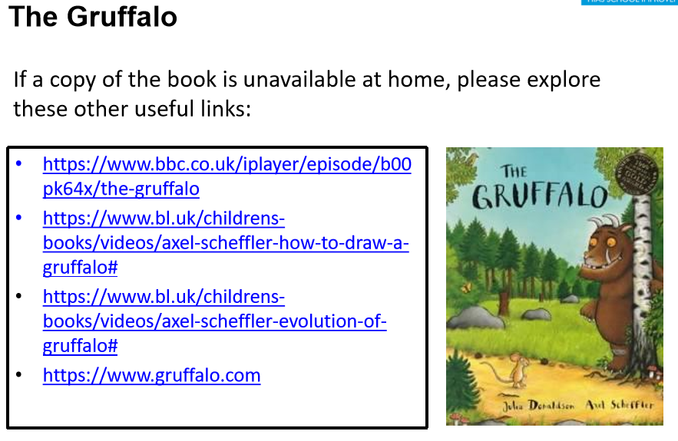
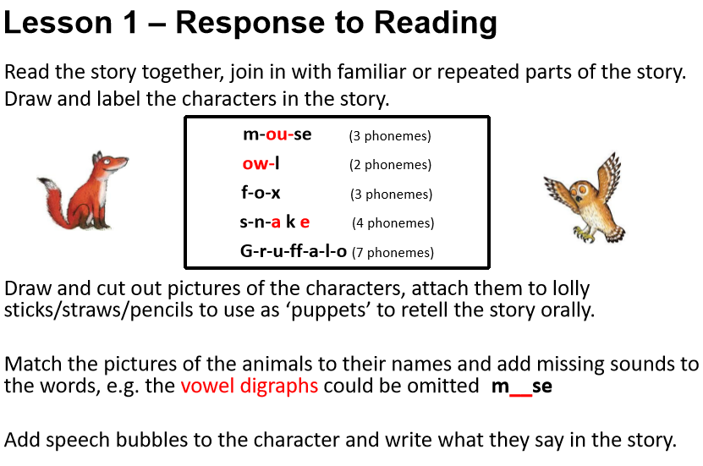
Literacy
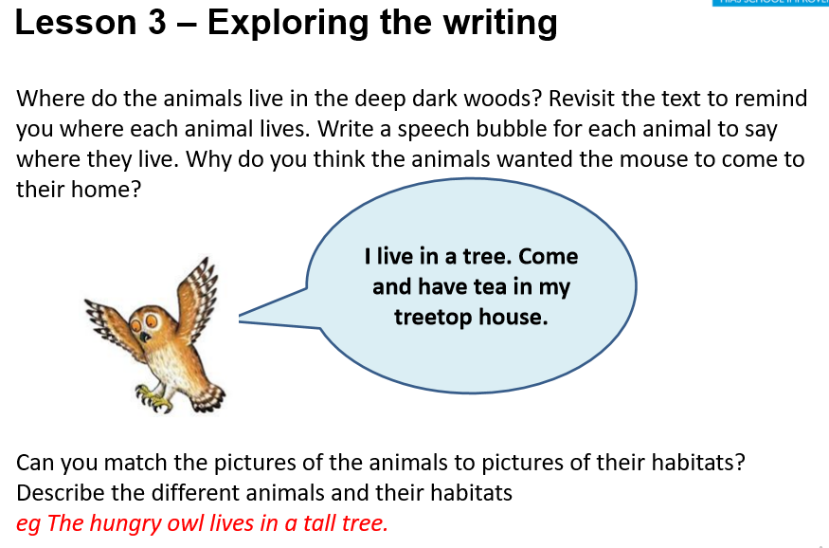
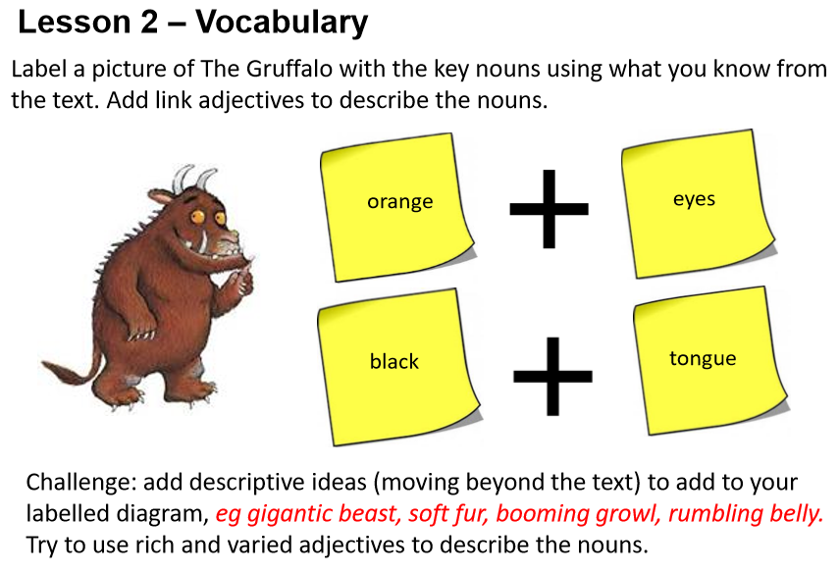

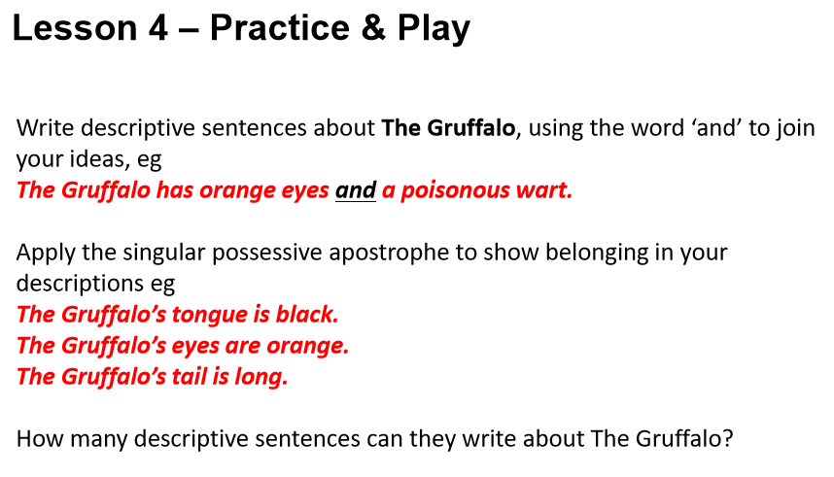
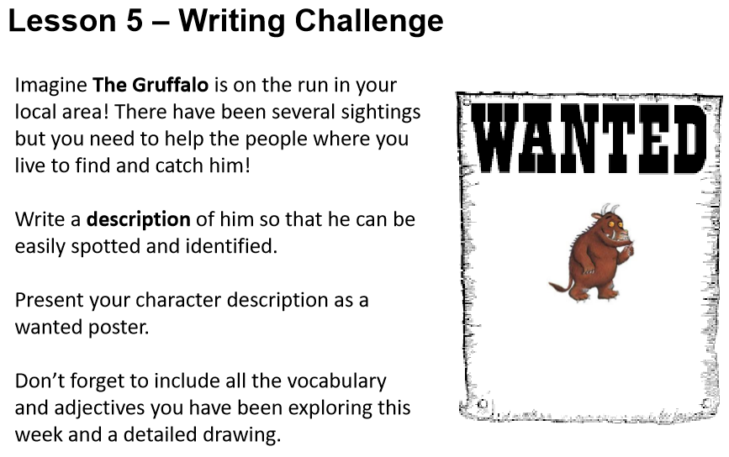

Maths
For maths this week, we will be working from The Oak Academy online lessons.

Year 1-Numbers 50-100 and Beyond
Click on the link below and scroll down until you get to the 10 lessons on Numbers 50-100 and Beyond.
https://classroom.thenational.academy/subjects-by-year/year-1/subjects/maths
Monday - Click on the Lesson 1. To recognise, read and write numbers to 100. The children will do an introductory quiz online, video tutorial with questions and a final quiz.
Continue to work through lessons 2 5 during the week.

Year R- Doubling and halving
Click on the link below and scroll down until you get to the 5 lessons on Doubling and halving (you have to scroll down the page a long way).
https://classroom.thenational.academy/subjects-by-year/reception/subjects/maths
Monday - Click on the Lesson 1. Understand the concept of double. The children will watch a video and then do the activities.
Continue to work through lessons 2 5 during the week.

Other Activities
This week we are using the Home Study Resource ‘Get Moving!’ produce by Hampshire. We are encouraging children to try three of the suggested activities in the pack which you can find attached as a PDF. Have fun!

