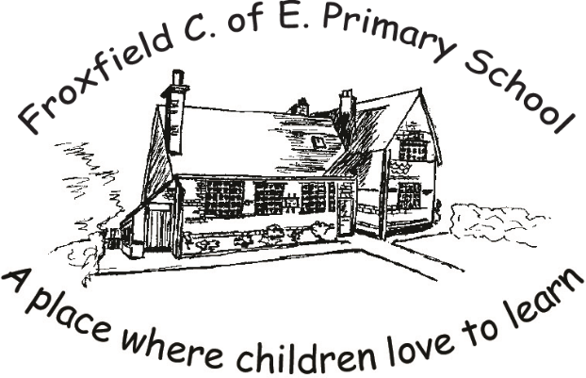

Week beginning Monday 22nd June
Year 5
This week, we turn our Literacy focus away from fiction, to information texts. The Mayans were a fascinating civilisation and I really hope that you enjoy and are amazed by some of the facts you will find, to write your non-chronological report.
In Maths we will be revising BIDMAS, a favourite in the classroom!
Your extra tasks are Music, Science and French. You might like to look at the Music task early in the week as it could be used as part of your Literacy learning.
Thank you for sharing your work with me on Class dojo, I love seeing the learning you are doing and remember you can send me messages as well to let me know how it is going for you. Keep in touch!

Mrs H

