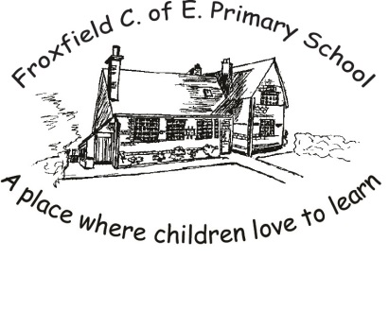
Spelling Card 2
Phase 4 |  |  |  | Phase 5
went |  |  |  | I’m
it’s |  |  |  | by
said |  |  |  | time
have |  |  |  | house
like |  |  |  | about
so |  |  |  | your
do |  |  |  | made
some |  |  |  | came
come |  |  |  | make
were |  |  |  | here
there |  |  |  | saw
little |  |  |  | very
one |  |  |  | looked
when |  |  |  | called
our |  |  |  | asked
what |  |  |  | their
out |  |  |  | where
 |  |  |  | work
 |  |  |  | friends

