Extra task 3: Geography

You may be surprised to know that the area around San Francisco is an earthquake zone. Look at the following websites to find out how many there have been in recent years and what risks are associated with them.

https://earthquaketrack.com/v/sf/recent
https://www.earthquakesafety.com/earthquake-history.html (apologies that this one is full of adverts, beware of them!)

These tell us information about the force of an earthquake, which is measured on the Richter Scale.

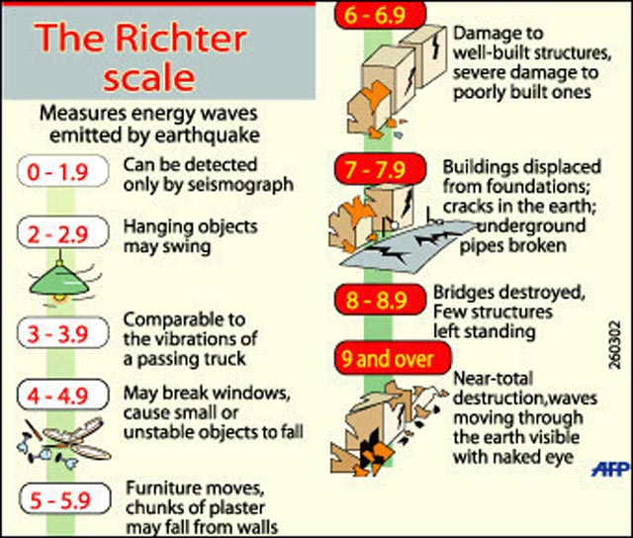

Use the information to find out what causes earthquakes, and some of the dates and sizes of recent earthquakes around San Francisco. Record this information and the probable damage the earthquakes will have done.
(Year 6, this will build on your work in the Autumn 2 half-term last year.)

