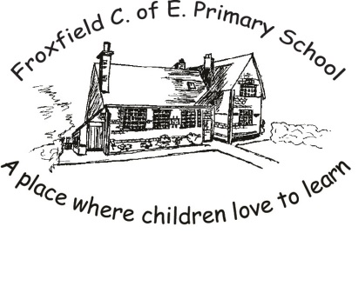
Spelling Card 6
actual |  |  |  | library
actually |  |  |  | minute
address |  |  |  | natural
breath |  |  |  | occasion
breathe |  |  |  | occasionally
centre |  |  |  | opposite
circle |  |  |  | perhaps
describe |  |  |  | popular
disappear |  |  |  | promise
eighth |  |  |  | purpose
enough |  |  |  | regular
extreme |  |  |  | remember
February |  |  |  | special
grammar |  |  |  | suppose
height |  |  |  | surprise
history |  |  |  | thought
imagine |  |  |  | through
interest |  |  |  | weight

