We can write four number sentences to match this array.
2 x 3 = 6
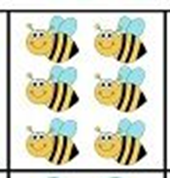
3 x 2 = 6

6 ÷ 2 = 3

6 ÷ 3 = 2

Write four number sentences to match each of these arrays

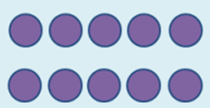
Now draw arrays to match these number sentences:
5 x 3 = 15
3 x 5 = 15
15 ÷ 3 = 5
15 ÷ 5 = 3

7 x 2 = 14
2 x 7 = 14
14 ÷ 2 = 7
14 ÷ 7 = 2

9 x 2 = 18
2 x 9 = 18
18 ÷ 2 = 9
18 ÷ 9 = 2

Finally match the array with the correct division statement.
20 ÷ 5 = 4
18 ÷ 2 = 9
15 ÷ 3 = 5
16 ÷ 8 = 2

