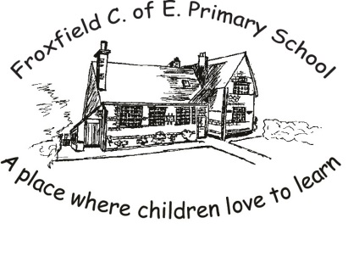
Spelling Card 3
after |  |  |  | kind
any |  |  |  | many
bath |  |  |  | most
because |  |  |  | move
both |  |  |  | Mr
child |  |  |  | Mrs
climb |  |  |  | old
cold |  |  |  | only
could |  |  |  | past
door |  |  |  | people
even |  |  |  | poor
every |  |  |  | should
fast |  |  |  | told
find |  |  |  | water
half |  |  |  | who
hold |  |  |  | would

