Homework:

Homework will be set each Friday, and is due to be handed in by the following Wednesday please (Thursday at the latest). Class spellings will be given out each Friday and the test will be the following Thursday. Each child will be given five spellings to learn each week – we are focussing on five so the children can consolidate these words and apply them in their writing. Table practice will be a priority throughout this year. Any practise children can do at home is hugely beneficial. Please also continue to work on Maths Challenge cards and telling the time at any opportunity. It really helps! Thank you for all your support.

Class information:

We encourage all children to bring in a water bottle each day. The water bottle must be a pull-up top and the fluid only water please!

This half term P.E is on a Monday and a Tuesday.

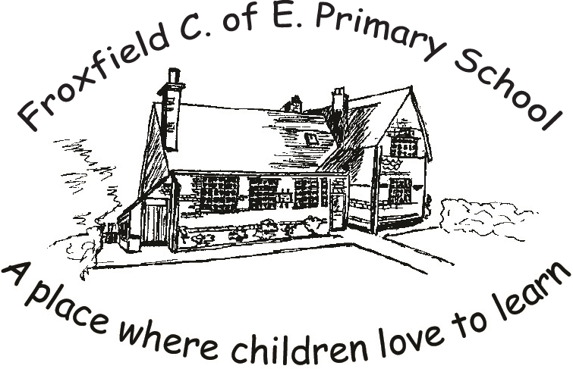

Autumn second half term
2020
Class 3
‘Deadly 360’
(Desert Biomes)

Literacy
Literacy learning this term will be based around the text ‘The Butterfly Lion’ by Michael Morpurgo. Class 3 will be writing their own book review at the end of this unit to recommend it to other children around the school and writing a leaflet based on the book.

Maths
In Maths Class 3 will be working on addition and subtraction in the context of money and length. We will also focus on multiplication and division, fractions and geometry.

Science
Our Science focus this half term is living things and their habitats. We will be identifying different habitats around the world and investigating how living things adapt to their environment.

Computing
We will be creating our topic cover using Word. This will involve the skills of importing images and manipulating text.

Religious Education
Our concept this half term is ‘Angels’ in the context of Angels as God’s messengers.

Physical Education
PE for Class 3 will be on Mondays and Tuesdays. We will be having Aspire on Mondays and dance on Tuesdays. Please ensure your child wears their P.E kit on these days and has trainers in school at all times.

Music
In music we will be learning songs through Maketon.

PSE – Personal and Social Education
This half term we will be working on how to treat each other with respect and learning about inclusion.

French
In French we will be learning simple classroom instructions and vocabulary around animals; reinforcing our prior learning on colours.

Geography
We will be learning about the deserts around the world looking at maps and atlases. We will also compare their climate to ours and investigate biomes. Alongside our science learning we will look at the animals and plants that live there and how they adapt to the environment.

DT
In DT this half term, we will be designing, building and evaluating a night light lamp box.

