What will I put in my box?
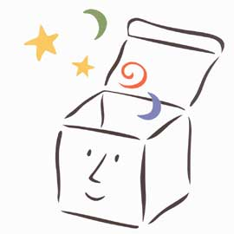

Choose your three favourite ideas and write as expanded noun phrases. Try to think of powerful adjectives. Use the word bank to help if you need to.

Objects (Remember to change a to an if you need to.)

A ________________________________________________________________________

A ________________________________________________________________________

A _______________________________________________________________________

Smells

The smell of ______________________________________________________________

The smell of ______________________________________________________________

The smell of ______________________________________________________________

