Homework for this learning cluster.
Homework will again be given out each Friday and is due to be handed in the following Wednesday. Spellings to learn will be brought home each Wednesday, for a test the following Wednesday. Tables’ tests will be held each Monday.

Revision Cards.
Year 6 will continue to bring home revision cards. Please can you find a regular short slot to go through them with your child, using them to prompt questions, to keep our learning fresh in their minds.

Class information.
We encourage all children to bring in a water bottle each day. The water bottle must have a pull-up top and the fluid only water please!

A reminder of the PE kit:
School T-shirt and shorts
T-shirt, warm top, long trousers and trainers for Aspire games
Socks to wear to replace tights
Hair ties to tie back long hair
Trainers
Plimsolls for indoor PE (optional)
Please can you also send in a carrier bag to put the trainers in through the winter months.

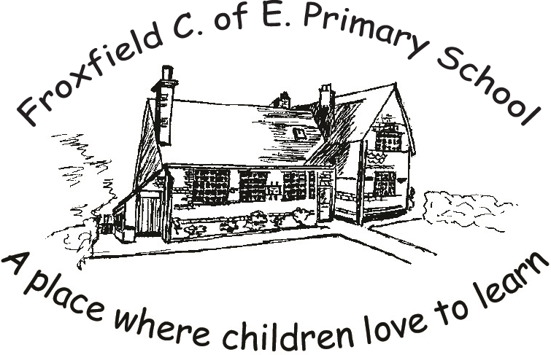

Spring second half term
2020
Class 4
‘Great Danes’

Literacy
The Literacy for this half term will be based on Shakespeare’s play – Hamlet (who was a Danish prince.) The children will use this to write an equivalent version with a modern setting and to create a newspaper report of the tragic final day in the play.

Maths
This half term there will be a focus on problem solving and mathematical reasoning. We will be encouraging the children to explain their steps to solving challenges. We will also link our maths learning to our topic of Denmark through graph work, beginning with exchange rates.

Science
In Science, we will be considering the impact of diet, exercise, drugs and lifestyle on the way human bodies function.

Computing and E-safety
Our computing will develop our learning of PowerPoints, specifically through the use of hyperlinks. We will apply this to our Geography learning about Denmark.

Religious Education
Years 5 and 6 will consider the key concept of ‘Resurrection’ within the context of ‘The Empty Cross.’.

Physical Education
PE for Class 4 will again be on Mondays and Tuesdays. Aspire Coaching will work with the class on Mondays, whilst the other focus will be on stamina, balance and agility within athletics.

PSE – Personal and Social Education
Our PSE focal points this half term will be ‘Good to be me’ and ‘Taking responsibility for my own safety.’ These will link well to our ongoing work in other areas of the curriculum.

French
In French our learning will be linked to our Art topic, by naming colours within the colour-mixing wheel. We will also be learning the key vocabulary for geometric shapes, alongside revising our responses in basic conversation.

Geography
Our main topic focus is to learn about a European Region, Denmark. We will be finding out about its land use, the major cities, rivers and the resources which support their economy.

Art
We will be learning about perspective and identifying complimentary and contrasting colours, by creating a painting using works by the Danish artist Anna Ancher as our stimulus.

Music
This half term we will continue with our focus on the voice, in the context of the songs for the Schools’ Choir Music Festival.

