
Adjective Word Bank
Appearance
Shape/Size
adorable
adventurous
aggressive
alert
attractive
average
beautiful
blue-eyed
bloody
blushing
bright
clean
clear
cloudy
colourful
crowded
cute
dark
drab
distinct
dull
elegant
excited
fancy
filthy
glamorous
gleaming
gorgeous
graceful
grotesque
handsome
homely
light
long
magnificent
misty
motionless
muddy
old-fashioned
plain
poised
precious
quaint
shiny
smoggy
sparkling
spotless
stormy
strange
ugly
ugliest
unsightly
unusual
wide-eyed
broad
chubby
crooked
curved
deep
flat
high
hollow
low
narrow
round
shallow
skinny
square
steep
straight
wide
big
colossal
fat
gigantic
great
huge
immense
large
little
mammoth
massive
miniature
petite
puny
scrawny
short
small
tall
teeny
teeny-tiny
tiny

Adjective Word Bank
Sound/
Touch

Taste/ Smell
cooing
deafening
faint
harsh
high-pitched
hissing
hushed
husky
loud
melodic
moaning
mute
noisy
purring
quiet
raspy
resonant
screeching
shrill
silent
soft
squealing
thundering
voiceless
whispering
boiling
breezy
broken
bumpy
chilly
cold
cool
creepy
crooked
cuddly
curly
damaged
damp
dirty
dry
dusty
filthy
flaky
fluffy
freezing
hot
warm
wet
bitter
delicious
fresh
juicy
ripe
rotten
salty
sour
spicy
stale
sticky
strong
sweet
tart
tasteless
tasty
burnt
clean
flowery
fragrant
fresh
fruity
minty
new
old
rainy
rotten
salty
sharp
sour
spicy
strong
sweet



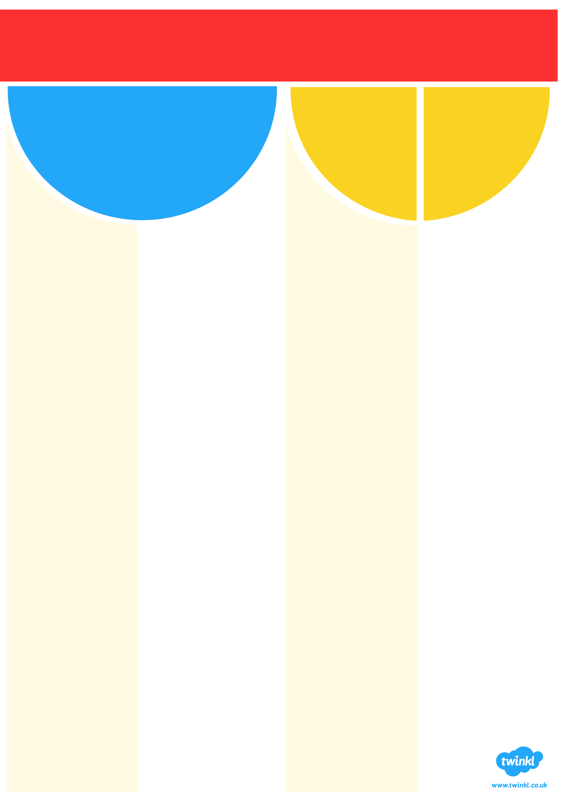
Adjective Word Bank

