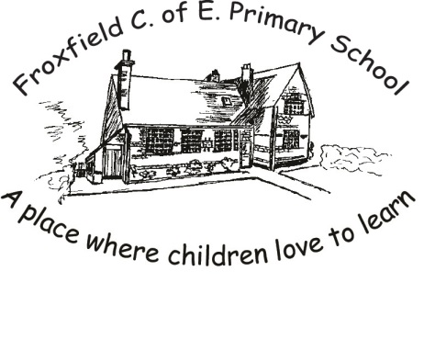
Spelling Card 1

Phase 2 |  |  |  | Phase 3
as |  |  |  | that
at |  |  |  | this
in |  |  |  | then
is |  |  |  | with
it |  |  |  | now
of |  |  |  | down
off |  |  |  | look
and |  |  |  | too
his |  |  |  | he
up |  |  |  | she
but |  |  |  | we
put |  |  |  | me
not |  |  |  | be
get |  |  |  | was
the |  |  |  | you
to |  |  |  | they
I |  |  |  | all
no |  |  |  | are
go |  |  |  | my
into |  |  |  | her

