Designing a Hand Puppet.

We would like you to design your own hand puppet. Your hand puppet can be any type of pond creature.

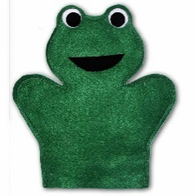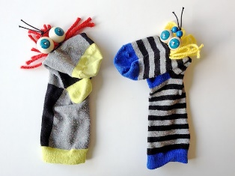

You will need to think about the material you will use for the body of your hand puppet. Eg. felt or cotton. Think about other materials you will need for the features of your pond creature. Eg. buttons for eyes.

To make sure your puppet is the right size for your hand you will need to draw around your hand.

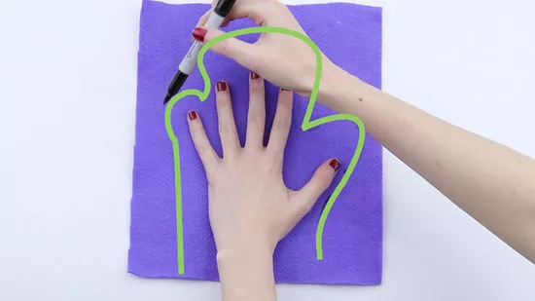

Please use the design sheet on the next page to show your ideas.

Have Fun! We can’t wait to see your designs.

Designing my Pond Creature Hand Puppet.

My puppet will look like this:

Make sure you label the important features!

These are the materials I will use:

_______________________________________________________________

_______________________________________________________________

