Week beginning Monday 18th May – Year 6 Maths
Today our focus stays with fractions.
Task 3
Please follow this link to the Whiterose Maths page.
https://whiterosemaths.com/homelearning/year-6/
Find Summer Term – Week 3 lesson 3 – It will look like this.

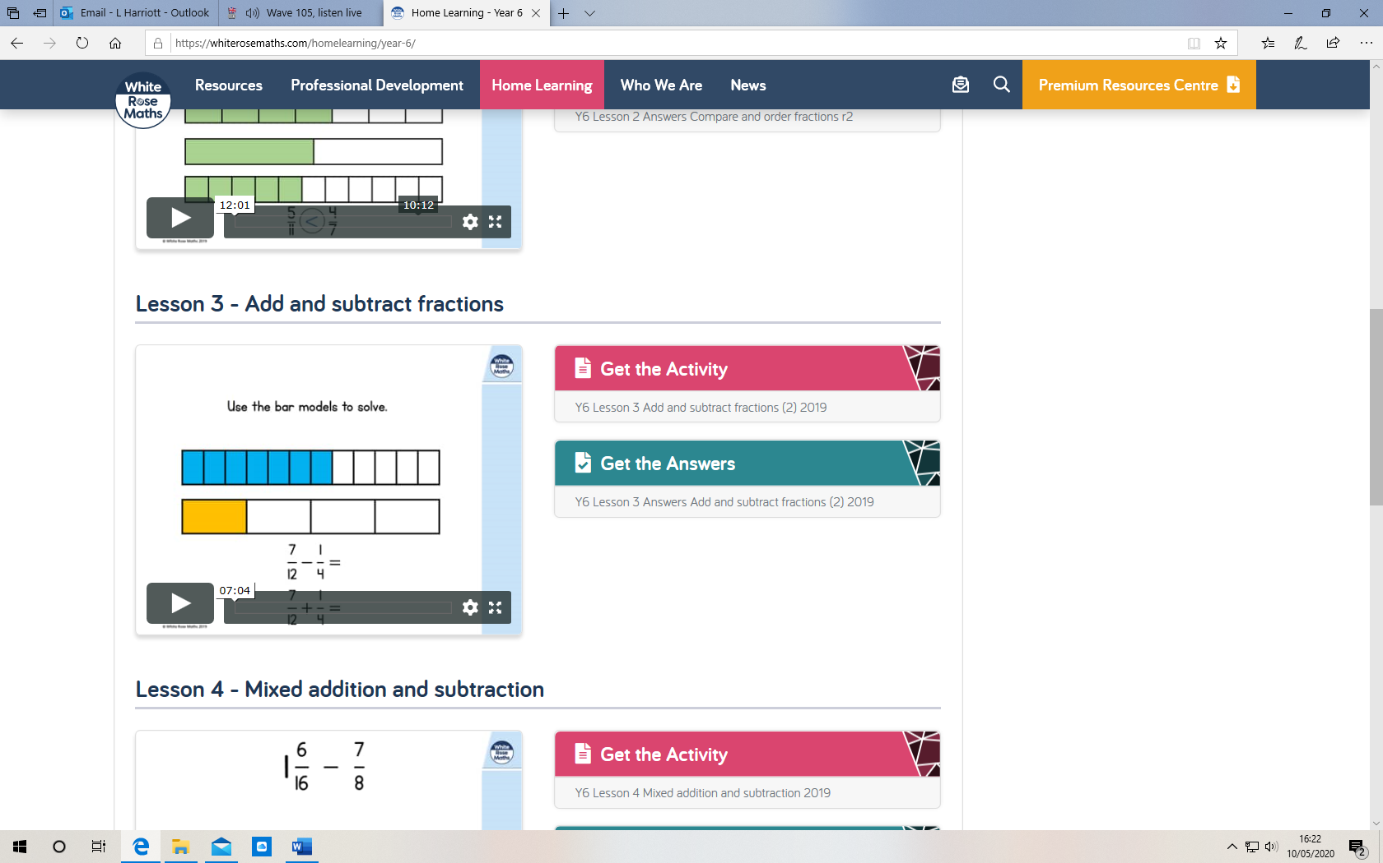

Play the video which is in the big box to the left.
Next, answer the questions in the ‘Get the activity’ section to the right of the box please.

